TROUP COUNTY REPORT TO THE
COURT IMPROVEMENT INITIATIVE ALL-SITES MEETING
WINTER, 2020
Conference website: http://www.gacip.org/cii-resources/

Objective Statement:
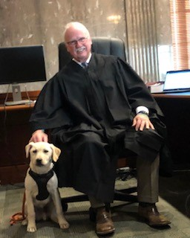

To ensure that every child that should be in care is in care, but not a single child more;

To ensure that every child that is in care is in a safe, nurturing placement that is supportive of the permanency plan for the child and ensures the child’s well-being.

Safe Reduction of the Number of Children in Care:

We continue to focus on individualized child welfare practice by trying to do the right thing for the right people in the right way at the right time. We believe if we do that, then we get the right results in individual cases and in our overall caseload. In April, 2018, we began to address what we considered to be a higher number of children in care than should be in care. At that time, we had 158 children in care. We have safely reduced the number of children in care to 100, a 36.7% reduction in just less than two years. As stated in our last report, we #BELIEVE (a shout-out to our Trauma Project tag line of “Be Positive, Be Strong, #Believe”) we can continue that downward trend. Data should inform, but not drive, practice, so we have not set a specific number as a goal, but there is still room for more reductions, most likely to between 75 to 90 children in care.

Avoiding Unnecessary Removals:

As part of our efforts to safely reduce the number of children in care, DFCS continues to do exceptional work avoiding removals. When confronted with a potential removal, we are focused on keeping the child safe just for a couple of days until we can have an expedited hearing. That gives DFCS time to explore options other than removal. In some cases, relatives or other caregivers can be located that will agree to keep children for a limited time even though they may not be a long-term placement resource. When we can find a way to keep the children safe until we can get to an expedited hearing, we can be very creative in keeping children out of care at the hearing though the use of alternatives to foster care, voluntary placements, or other means. The pre-removal staffings are effective, particularly when coupled with strong judicial oversight when the call is made to the judge following the staffing. The more we can delay removal to foster care, the better chance we have to find ways to keep families together through court-ordered family preservation or other options.

Operation Home Team Protocol, Service Provider Protocol for Assessments and Evaluations, Service Protocol for Ongoing Services, My Case Plan Summary, Practice Guide for the Placement of Children, and the Program Improvement Plan:
We have continued to implement all of the above-named protocols, guides and plans (referred to hereinafter jointly as “Practice Guides”) with varying degrees of fidelity. We recently made a commitment to move to full compliance beginning March 1st. Copies of the Practice Guides are posted on the conference website. The Program Improvement Plan (the “PIP”) is a system-wide improvement plan involving DFCS, the Court, all attorneys, CASAs and service providers. Generally, the PIP involves creating a need centered and trauma-responsive, success focused culture, which includes, parental and child engagement, improved case planning, implementation, and monitoring, more engagement in case planning, implementation and monitoring by all of the attorneys and CASAs in the case, reinstituting Permanency Roundtables, improving service delivery, utilizing the Enhanced Resource Guidelines Bench Cards, complying with the Visitation Protocol (now the Family Practice Guide discussed hereinafter), improving placement practices, more judicial oversight, development and growth of our Family Treatment Court, incorporation of more features of the Family Treatment Court in regular dependency court, and continued and increased focus on the reason children cannot be maintained at home safely.

In 2019, we began a top-to-bottom review of the Practice Guides to determine the level of compliance, the barriers to compliance, changes that may need to be made, and overall effectiveness. Having identified 207 separate and distinct action items in the Practice Guides, we found that the process is more time consuming thananticipated. To move this work forward, beginning in March we will try to review at least one portion (more than one action item) at each of our monthly stakeholder meetings.

Becoming a Need-Centered and Trauma-Responsive Court/Community:

The Troup County Trauma-Responsive Community Project (the “Project”) has been involved in this work for six years now, but we have made most of our progress within the last three years.

As a result of this work:

- There is a much greater awareness throughout the community about trauma and the impact of trauma on children, families, and the community at large.
- The school system has made great strides in implementing, not just some level of trauma informed care, but also of addressing mental health generally.
- We have trained most P.O.S.T. certified officers of the LaGrange Police Department and the Troup County Sheriff’s Office using a P.O.S.T.-certified training regarding the impact of trauma, which we designed specific for law enforcement. Our goal is that, if law enforcement responds to a call anywhere in the County, the officers responding would have had at least some level of training about trauma. At one point in time we could say that all of the Court (Court staff and attorneys) and all of DFCS had received the two-day training offered by the Georgia Child Welfare Training Collaborative (the “Collaborative”), but we have a number of new employees at both agencies and attorneys who have not had the training. Given the trauma training we do locally, we have asked the Collaborative to develop a shorter basic course and we will send everyone who has missed the original training to go to the shorter version.
- We implemented Handle with Care, memorialized in a Memorandum of Understanding between the school system and all four law enforcement agencies in the county. Under the MOU, if a child is exposed to a traumatic event, the child’s school is notified of the child’s name and age before the child arrives at school the next school day so that the school can handle that child with care. A copy of the MOU is posted on the conference website. We will be having a meeting soon to review compliance and results and to likely add animal control and the Marshall’s Office to the MOU.
- We were one of four courts nationally selected to pilot a Trauma Informed self-assessment toolkit developed as a joint project of the National Child Traumatic Stress Network and the National Council of Juvenile and Family Court Judges. The toolkit was designed for juvenile justice, but the things we implement around juvenile justice also transfers over nicely to dependency. We have implemented a lot of the things identified through the self-assessment, but we are starting over to some extent as we have all new probation officers since we worked through the toolkit the first time. The toolkit is now available to all courts at https://www.nctsn.org/resources/trauma-informed-juvenile-court-self-assessment.
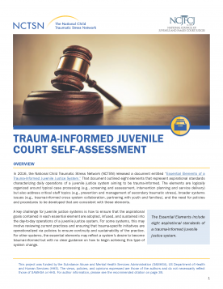
- A fundamental element in being a trauma responsive court is creating an environment where all people entering the courthouse feel physically and psychologically safe. As important as all of the individual pieces of the trauma project are, the real key to being a trauma responsive court is creating a trauma responsive culture, and that involves people and things. Getting all of the people involved with the court to buy in to the importance of being trauma responsive, getting them educated on what it takes to be trauma responsive, and putting all of that to work takes time and multiple leaders, not just one person. Having a physical environment is another key piece. Following are just some of the things we have done: opened the blinds in our courthouse; placed flowers on the window seals in the courtroom; made all three of our waiting rooms people-friendly and as warm and comfortable as a waiting room in a courthouse can be; put monitors in all three rooms to play informational and inspirational programs all day long; provided snacks and water; and enlisted two court ambassadors, two angels from our faith community who work the waiting rooms and courtroom on dependency days making sure people’s needs are being met and relieving as much stress as possible. Also, as soon as Donut, the LaGrange Police Department therapy dog, gets back from training, he will be visiting with us on dependency days when his schedule permits.
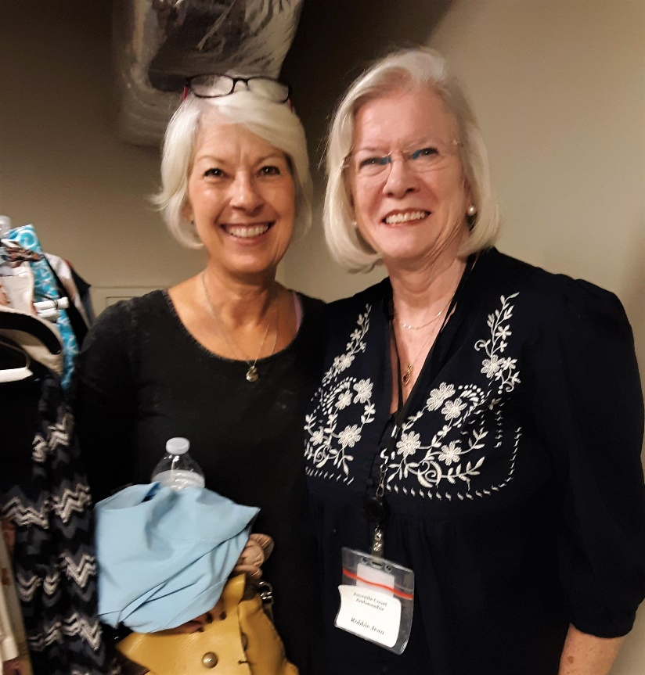
- In an effort to improve outcomes for individuals and families served by the Court and its community partners, we have started to really focus on identifying individual needs, matching the right services to meet those needs, and improving the exchange of information at all levels. This effort has been combined with our trauma work to become a Need-Centered and Trauma-Responsive Court/Community. We are making more efforts than ever in case planning, implementation and monitoring to make sure we are identifying and meeting the needs of children and parents in dependency cases. Beginning at the disposition hearing and continuing throughout the life of the case, the judge reviews every assessment and evaluation in court to give everyone an opportunity to participate, and the Program Improvement Plan puts more responsibly on the attorneys to participate in case planning, implementation and monitoring. Being need-centered has contributing to the safe reduction of the number of children in care.

On the conference website in the Articles by Judge R. Michael Key folder are articles entitled Is Justice Really Enough and But I am not Soft!, written by Judge Key and published in the January, 2019 and January 2020 editions of the Georgia Courts Journal.

Family Time Protocol:

We are in the process of implementing the Family Time Practice Guide. Having been in compliance with the Visitation Protocol is making it easier to implement the frequency and duration provisions of the Family Time Practice Guide. DFCS is implementing frequency and duration provisions in the Family Time Practice Guide in phases by age group. They started with ages birth to three and have expanded to ages four and five. Through the amazing work of Sheriff James Woodruff, DFCS and West Georgia Counseling and Assessment, with support from other stakeholders, we have started visitation between children in foster care and their incarcerated parents. It is safe to say this has been one of the most satisfying accomplishments our court and stakeholders have experienced. Pictured here is what Sheriff Woodruff calls the Reunification Room. The picture was taken when the MD CANI Team visited the jail. Sheriff Woodruff loves to show the room off if you ever want to visit.
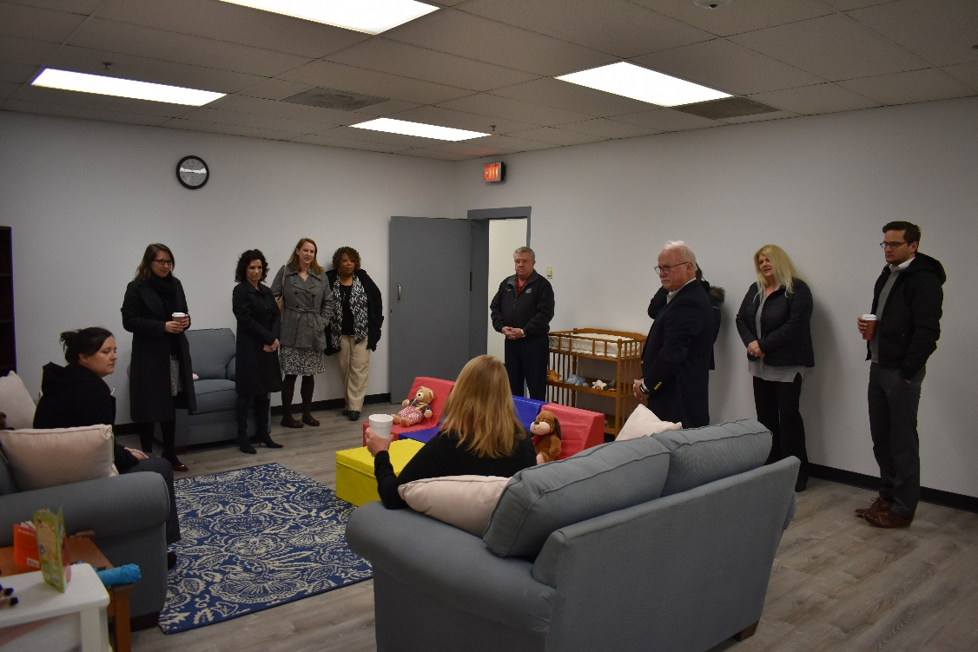

On the conference in the Articles by Judge R. Michael Key folder is an article entitled A Very Special Thanksgiving…at the Troup County Jail” written by Judge Key and published in the January, 2019 and January 2020 editions of the Georgia Courts Journal and the latest draft of another entitled The Judge’s Role in Ensuring Meaningful Family Time to be published in March in CBX, a publication of the Children’s Bureau.

Family Treatment Court:

We continue to grow our Family Treatment Court. As we approach the end of our second year, we are at capacity (20) and normally a couple above capacity. We are hoping to increase our capacity to 30 in the upcoming fiscal year. We attribute a lot of our removal avoidance and reduction in our foster care population to the Family Treatment Court. One fun and meaningful project we launched last year is our accountability store. Modeled after Positive Behavior Incentives and Supports (“PBIS”), we acknowledge varying levels of compliance with the traditional praise, but also with tangible acknowledgements which we call Accountability Bucks, which can be used to purchase items in our Accountability Store. Our County Administration is so excited about the store that they have launched a donation drive for staples for the store. It has been extremely well-received by the participants as well. Our challenge now is that we have outgrown our space.
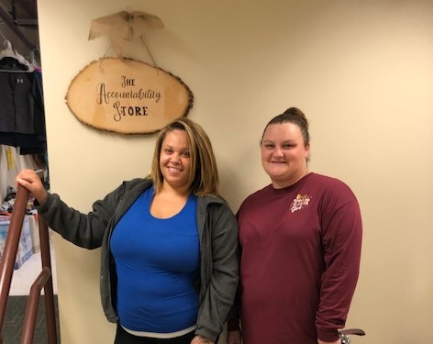

On the conference website in the Articles by Judge R. Michael Key folder is an article entitled Troup County Family Treatment Court written by Judge Key and published in the December, 2019 edition of the Council of Accountability Court Judges Newsletter.

Court Appointed Special Advocate Program:

Our CASA program has made great strides in the last eight or nine months, going from a program that was mostly a professional GAL program where staff handled the majority of the cases, to a robust program with enough volunteers to serve all of our children in care. They are using the new CASA report, showing up in court in larger numbers than ever before, and filing meaningful reports on time. We are all very proud of our program. On the conference website in the Articles by Judge R. Michael Key folder is an article written by Judge Key entitled The Second Greatest Love of All and published in the December, 2019 Issue 36 of the E-News for CASA Network in Georgia.

County Practice Guide:

In implementing the foregoing practices, we are addressing the best practices set out in the County Practice Guide as follows: PP6, FL1, FL5, FL6, FL7, FL8, FL9, FL10, LR3, LR4, LR5c, LR5e, CAA5, and CAA6f.

