TROUP COUNTY REPORT TO THE
COURT IMPROVEMENT INITIATIVE ALL-SITES MEETING
WINTER, 2021

Objective Statement:
To ensure that every child that should be in care is in care, but not a single child more;

To ensure that every child that is in care is in a safe, nurturing placement that is supportive of the permanency plan for the child and ensures the child’s well-being.

Safe Reduction of the Number of Children in Care:

We continue to focus on individualized child welfare practice by trying to do the right thing for the right people in the right way at the right time. We believe if we do that, then we get the right results in individual cases and in our overall caseload. In April, 2018, we began to address what we considered to be more children in care than should be in care. At that time, we had a high of 158 children in care. We have safely reduced the number of children in care to 68, a 57% reduction in just less than three years. We stated in our last report, a year ago, that we believed we could continue that downward trend. We also stated that data should inform, but not drive, practice, and that there was still room for more reductions, most likely to around 75 to 90 children in care. Now, with 68 children in care, we are not sure what the “right” number is as the number of children in care can be influenced by a number of dynamic factors. We can only control what we can control, which is continuing to implement and maintain fidelity to best practices while also making sure we do not lose sight of basic practices.

As an aside, we also looked at the number of family preservation cases now compared to April, 2018, and we were surprised to see that those cases have actually decreased from 114 then to 85 now. That number has been up and down since 2018, with 114 in April, 2018, up to 122 in April, 2019, down to 71 in April, 2020, and up to 85 now. 20 of the Family Preservation cases are court-ordered and the rest are voluntary, but there are 5 in the pipeline to be sent to the SAAG to seek court-ordered family preservation. We will continue to monitor and analyze all of these numbers to see what drives them.

Avoiding Unnecessary Removals:

As part of our efforts to safely reduce the number of children in care, DFCS continues to do exceptional work avoiding removals. When confronted with a potential removal, we are focused on keeping the child safe just for a day at a time or for a few days until we can have an expedited hearing. That gives DFCS time to continue to explore options other than removal. In some cases, relatives or other caregivers can be located who will agree to keep children for a limited time even though they may not be a long-term placement resource. Sometimes we are able to put enough services in the home to reduce the safety risk at least in the short term until we can get to a hearing. When we can find a way to keep the child safe until the expedited hearing, we can be very creative in keeping children out of care at the hearing though the use of alternatives to foster care, voluntary placements, supportive services and/or other options. The pre-removal staffings are effective, particularly when coupled with strong judicial oversight when the call is made to the judge following the staffing. The longer we can delay removal to foster care, the better chance we have to find ways to keep families together through court-ordered family preservation or other options.

Ongoing Focus on Reasonable Efforts:

We continue to make reasonable efforts central to all that we do. Even though not expressly required by law, in the coming months we are going to start formally making reasonable efforts findings part of our review of family preservation cases. We are working on a reasonable efforts checklist to guide in the delivery of services aimed at avoiding unnecessary removals to foster care, timely achieve reunification when children have to enter foster care, and timely achieve permanency through an alternative permanency goal. The checklist will also bring even more structure to making reasonable efforts findings.

Operation Home Team Protocol, Service Provider Protocol for Assessments and Evaluations, Service Protocol for Ongoing Services, My Case Plan Summary, Practice Guide for the Placement of Children, and the Program Improvement Plan:

We have continued at varying levels to implement all of the above-named protocols, guides and plans (referred to hereinafter jointly as “Practice Guides”) with mixed results. We have not been as focused driving system-wide implementation and ongoing monitoring as we would like to be since the start of the pandemic – not making excuses, just acknowledging the reality of fighting just to stay afloat and maintaining fidelity to the law and to basic practices while many stakeholders are working remotely and we are in court almost all day almost every day. Having said that, we have implemented one significant change in practice that is yielding great results in the nine months since we started, which will be discussed in the next section and will be the focus of our oral presentation at CII.
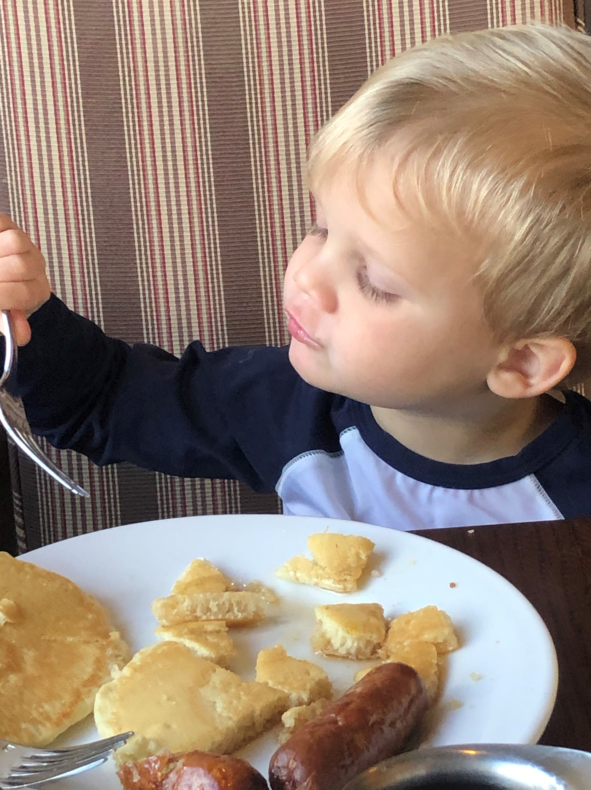

The Case Plan Dashboard, Child Passport and Service Provider Report:

At the beginning of the pandemic, we committed ourselves to come out of the pandemic better than we came into it, and we have. A real key to improvement in our handling of ongoing foster care cases has been the development and implementation of the Case Plan Dashboard, Child Passport and Service Provider Report, which we refer to collectively as the Dashboard. While DFCS still completes, generates and files the Shines case plan, the real focus for case plan implementation, monitoring and oversight is around the Dashboard. The key components to the Case Plan Dashboard are case plan requirements, compliance, progress and milestones. The requirements, compliance, and progress sections are set out in three columns for easy comparison, which produces a clear, meaningful picture of how the parents are complying and progressing with their case plans. The milestones section is the roadmap home for the children, targeting key dates for moving from supervised family time to unsupervised family time, to extended family time, to overnight family time, to trial home placement, and to return of legal custody. Some of the advantages of the Dashboards, which are filed not later than five business days prior to a hearing, are:

- The Dashboards are entered into evidence and the only direct testimony about requirements, compliance and progress is in the form of updates or possible errors, and testimony on cross-examination as to alleged errors and/or updates from the parents.
- By having this detailed, succinct information five business days in advance, parents and children’s attorneys can be more prepared for the reviews and hearings. They can also more easily help their clients understand where they are and what they need to work on.
- Updating the Dashboard in preparation for the hearing or review results in case managers being more prepared than in the past and seems to result in case managers being more confident and effective when they testify.
- Everyone involved in the review can simply compare the current Dashboard to the previous Dashboard or Dashboards to get a quick look at where the case is overall.
- The Dashboard is incorporated into the court’s findings, which builds a really good record for making reasonable efforts findings.
- There are built in reminders to continue to focus on the reason or reasons the child cannot be maintained at home safely, how long the child has been in care, a goal for the child to return home, diligent search updates, and independent living services where applicable.
- There is also a section that includes any directions or orders from the court at the prior hearing.
- A standard service provider report was developed collaboratively by DFCS, our main service provider (West Georgia Counseling and Assessment), Lori Davis and Dr. Pricilla Faulkner. This report provides the best information in the clearest format we have ever had routinely available to us in our court. While the case manager may summarize progress on the Case Plan Report, the Service Provider Report provides more detailed and current information.

Now that the Dashboard has been fully implemented in foster care cases and we have enough experience with it, we will begin implementing it in court-ordered family preservation cases in the near future. Using the Dashboard will bring to family preservation all of the advantages around case planning, implementation and monitoring that we have seen in foster care cases, including allowing for more meaningful work around reasonable efforts and reasonable efforts findings.

Becoming a Need-Centered and Trauma-Responsive Court/Community:

The Troup County Trauma-Responsive Community Project (the “Project”) has been involved in this work for seven years now, but we have made most of our progress within the last four years. Following is largely a repeat of our report from last year since the work is all ongoing.

As a result of this work:
- There is a much greater awareness throughout the community about trauma and the impact of trauma on children, families, and the community at large.
- The school system has made great strides in implementing,
not just some level of trauma informed care, but also of addressing mental health generally.
- We continue to offer training on trauma for the court staff and all of our stakeholders.
- We implemented Handle with Care, memorialized in a Memorandum of Understanding between the school system and all four law enforcement agencies in the county. Under the MOU, if a child is exposed to a traumatic event, the child’s school is notified of the child’s name and age before the child arrives at school the next school day so that the school can handle that child with care. A copy of the MOU is posted on the conference website. We will be having a meeting soon to review compliance and results and to likely add animal control and the Marshall’s Office to the MOU.
- We were one of four courts nationally selected to pilot a Trauma Informed Self-Assessment toolkit developed as a joint project of the National Child Traumatic Stress Network and the National Council of Juvenile and Family Court Judges. The toolkit was designed for juvenile justice, but the things we implemented around juvenile justice also bleeds over to dependency. We have implemented a lot of the things that we identified through the self-assessment; however, we were basically starting over last year to some extent as we have all new probation officers since we worked through the toolkit the first time. Our work during the last year has been slowed due to the pandemic. The current focus is on creating a juvenile court policy and procedure manual to include trauma informed court policies and practices. The toolkit is now available to all courts at https://www.nctsn.org/resources/trauma-informed-juvenile-court-self-assessment.
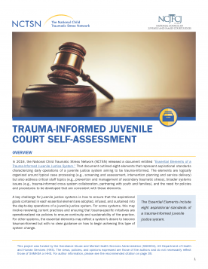
- A fundamental element in being a trauma responsive court is to create an environment where all people entering our courthouse feel physically and psychologically safe. As important as all of the individual pieces of the trauma project are, the real key to being a trauma responsive court is creating a trauma responsive culture and that involves people and things. Getting child welfare stakeholders to buy in to the importance of being trauma responsive, educated on what it takes to be trauma responsive, and then putting all of that to work takes time and multiple leaders, not just one person. A welcoming physical environment that is easy to navigate is another key piece. Following are just some of the things we have done: opened the blinds in our courthouse; placed flowers on the window seals in the courtroom; made all three of our waiting rooms people-friendly and as warm and comfortable as a waiting room in a courthouse can be; we added TV monitors in all three waiting areas to play informational and inspirational programs all day long; provided snacks and water; and enlisted two court ambassadors, two “angels” from our faith community who work the waiting rooms and courtroom on dependency days making sure people’s physical and emotional needs are being met.
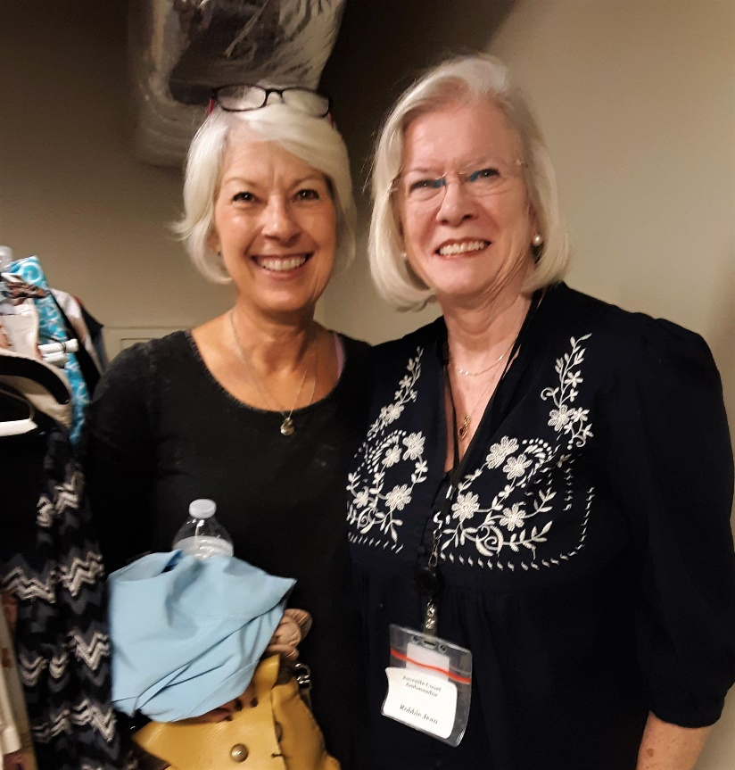
- In an effort to improve outcomes for individuals and families served by the Court and its community partners, we have started to really focus on identifying specific needs, matching the right services to meet those needs, and improving the exchange of information at all levels. This effort has been combined with our trauma work to become a Need-Centered and Trauma-Responsive Court/Community. We are making more strides than ever in case planning, implementation and monitoring to make sure we are identifying and meeting the needs of children and parents in dependency cases. Beginning at the disposition hearing and continuing throughout the life of the case, the judge reviews every assessment and evaluation in court to give everyone an opportunity to participate and the Program Improvement Plan puts more responsibly on the attorneys to participate in case planning, implementation and monitoring. Being need-centered has contributed to the safe reduction of the number of children in care.

Family Time Protocol:

We have implemented the Family Time Practice Guide, including the enhanced frequency and duration guidelines. In November 2019, through the amazing work of our Sheriff, James Woodruff, DFCS and West Georgia Counseling and Assessment, Troup County implemented a visitation program between children in foster care and their incarcerated parents. The program was interrupted by the pandemic but we have begun a discussion with the Sheriff about resuming it, if not fully in person, then, by providing virtual visitation. It is safe to say this has been one of the most satisfying accomplishments our court and stakeholders have experienced. Pictured here is what Sheriff Woodruff calls the Reunification Room. The picture was taken when the MD CANI Team visited the jail. Sheriff Woodruff loves to show the room off if you ever want to visit.
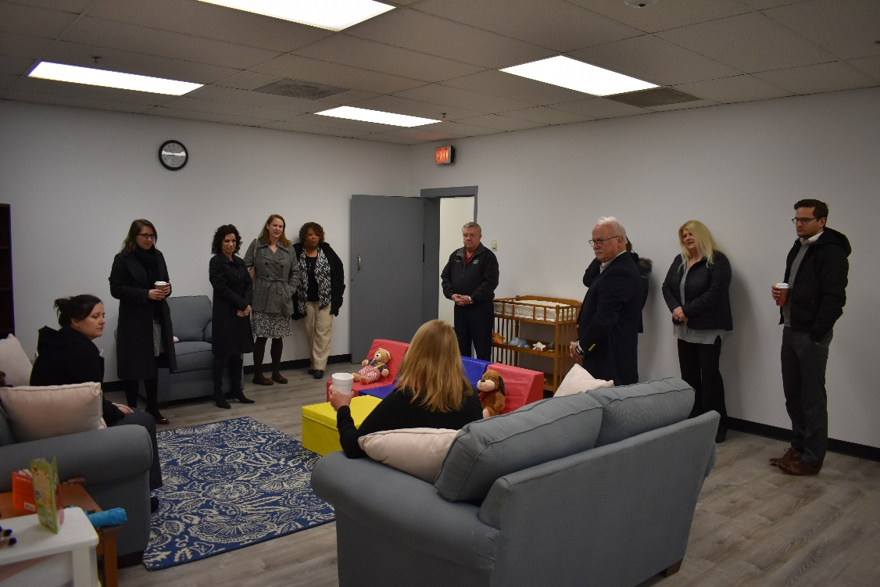

Family Treatment Court:
We give a lot of credit to our Family Treatment Court for our improved outcomes in foster care and in court-ordered family preservation. As we approach the end of our third year, we have maintained our capacity (20) and we have asked for funding to increase our capacity to 25-30 in the upcoming fiscal year. One fun and meaningful project we launched the year before last, is our accountability store. Modeled after Positive Behavior Incentives and Supports, we acknowledge varying levels of compliance with the traditional praise, but also with tangible acknowledgements which we call Accountability Bucks, which can be used to purchase items in our Accountability Store. Our County Administration is so impressed with the idea of the store that they launched a donation drive to include staples for the store. It has also been extremely well-received by the FTC participants. We had reached the point before the pandemic where we had so many donations, that we outgrew our space. We closed the store during the pandemic, but we are planning to re-open it on at least a limited basis. Our parents will have a lot of Accountability Bucks to spend because they have continued to earn them all along the way.
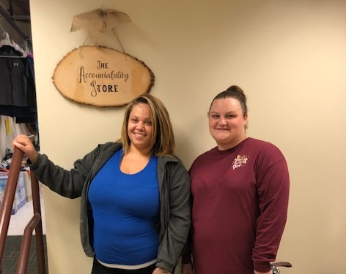

County Practice Guide:

In implementing the foregoing practices, we are addressing the best practices set out in the County Practice Guide as follows: PP6, FL1, FL5, FL6, FL7, FL8, FL9, FL10, LR3, LR4, LR5c, LR5e, CAA5, and CAA6f.

This is not an exhaustive list of references to the County Practice Guide as it has not been updated recently. CII Report.Winter 2021 March 9, 2021 10:05 pm Version

