Pre-Petition | Training for mandated reporters  (PP3) | A training in September is taking shape. DFCS is working with the Coweta County School Board who will provide a training auditorium for teachers, court staff, principals, assistant principals and counselors across the school system to receive training.
Case Assignment | Transition of case from one worker to another does not delay development or delivery of services to the family.  (CA3c) | Started Operation Permanency and Operation Family Preservation transfer staffing in February. This effort started strong – we will continue to focus those efforts to improve
Front end loading | Includes the plan for visitation between the child and parents not placed together (15-11-201(b)(8) and 15-11-112 (court-ordered visitation)); DFCS Policy Manual Chapter 10, Foster Care, Policy # 10.19, Visitation)  (FL5f) | Gretchen Cleveland, our DFCS director, knew of a grant she felt could help with taking foster care visits out of fast-food restaurants and into a more meaningful environment. She also was looking to engage a veteran foster parent falling out of touch, so she informed her of the idea. That foster parent has a background in fundraising and non-profits, so she turned the idea into a reality quickly. The Court facilitated a meeting with local attorneys who volunteered their time and money to create the business entity and to navigate the IRS rules for non-profits. Hope Revisited opened their doors August 1, 2021. https://hoperevisited.org/  Parents will be able to visit with their children in a home in downtown Newnan. That home has been divided into apartments, so several visits can occur at once. Trained staff will supervise at a distance. Parents can cook a meal for their kids, wash laundry, watch a movie, play games, put a small child down for a nap. We eventually want to have parent aides help with nutrition classes, budgeting, and other skills needed to effectively parent.
Reports | Court has policy permitting email service of GAL and DFCS reports. See URJC 29:Electronic Filing in Juvenile Court.  (R3) | We’ve allowed filing GAL reports and dispositional reports by email for some time now. However, we have now made it official with a standing order allowing those to be e-filed, along with opposition to change in placements.  I would like for this issue to be discussed at our Fall meeting in Athens.
Courthouse Facilities | Courtroom facilities have been designed/ modified in consideration of the needs of victims of trauma.  (CF2B) | 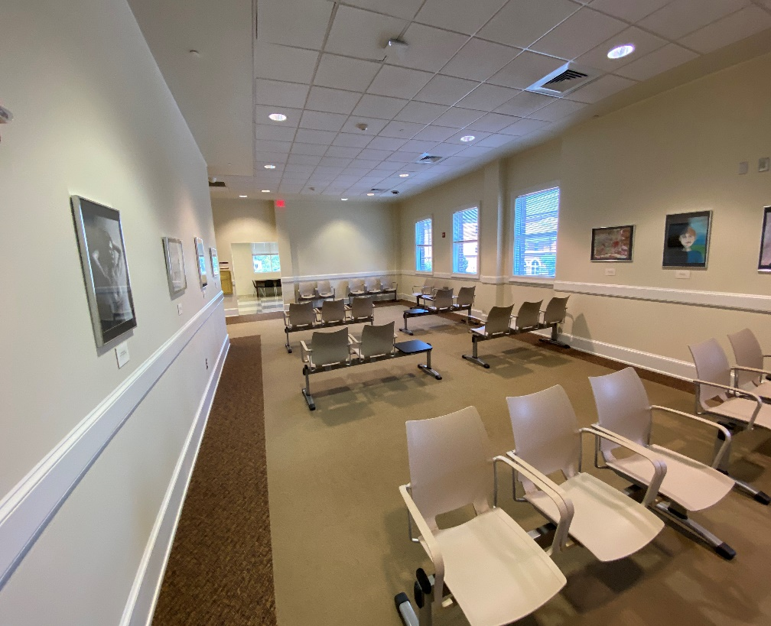  The lobby area is now safer for individuals coming in to testify. Only one case is called at a time, and cases are now set at specific times, usually 45 minutes to 1 hour apart. If the attorneys let us know the case will take longer than an hour, the case is given the time requested on our regular dependency days, or specially set. No more cattle call calendars. Individuals concerned about FV may wait in an identical waiting area on the opposite end of the building.
Courthouse Facilities | Courtrooms have separate tables for SAAG/agency worker, counsel/parent, and Child Advocate Attorney/child.  (CF1) | 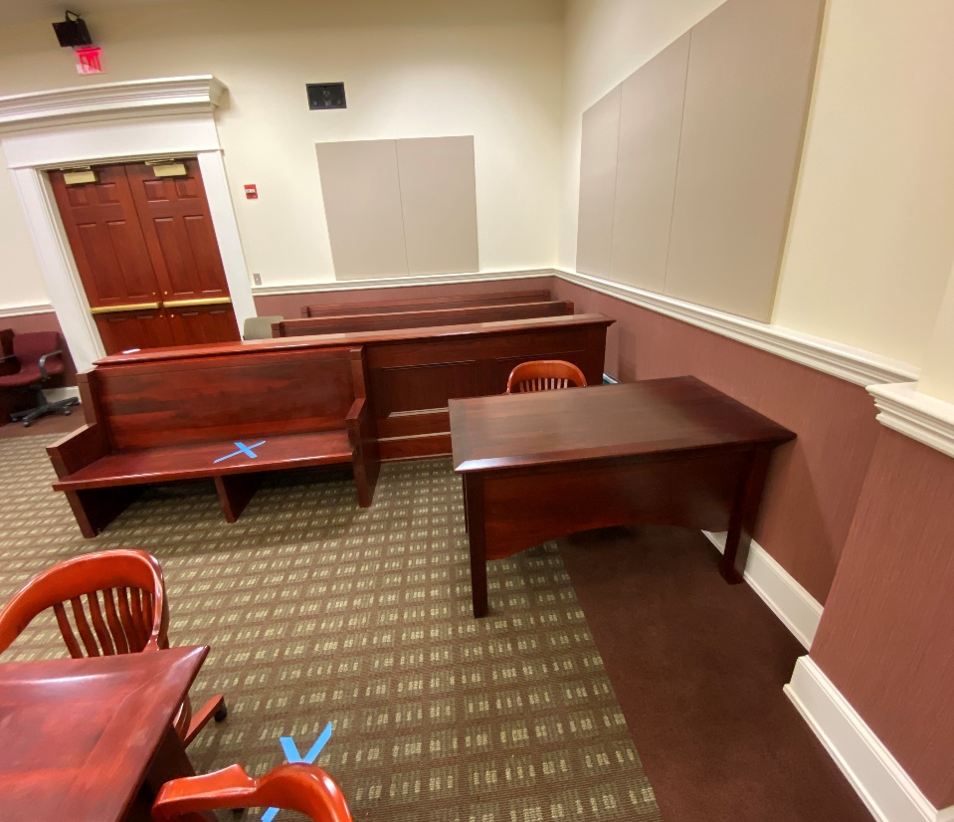  We have a small courtroom. To accommodate an independent table for the GAL and child, we had to cut out an area in front of the bar. We got county prisoners to build a custom table. We are waiting for IT to wire it with a microphone, monitor and network port. We are contemplating hanging pictures of clowns on the walls to make it more “child friendly.” (See CF2)
Hearing Quality | Parent’s tasks before next hearing  HQ2 | We need to ensure parents understand what is expected of them before the next hearing.  I’ve been told I sometimes go too quickly, or use stilted language. (Honestly, I fail to comprehend this apprehension, and find it rather impertinent)
FTC | Community Project | The latest project is behind the Juvenile Court building, in an unused gated area. A Phase 4 participant is creating a raised garden. So far, he’s engaged the local prison (they have a remarkable garden and gardeners), a local mulch company who donated the topsoil, others in the community who doanted the lumber. He will start off the garden with winter vegetables, and kids will be able to help their parents tend the garden, harvesting and eating what they grow.  