Courthouse Facilities
We have a small courtroom and due to COVID-19, we have not been able to safely accommodate large numbers. In March 2020, we transitioned to Zoom hearings. We found that some parents had unreliable internet and some were having difficulty scanning, converting and uploading documents. Through a J4C technology grant, we were able to secure a scanner, monitor and chromebook. We also used our small equipment budget to equip our courtroom with additional cameras and microphones.
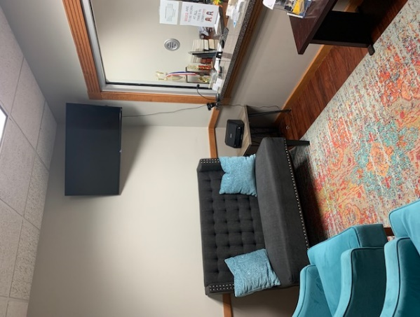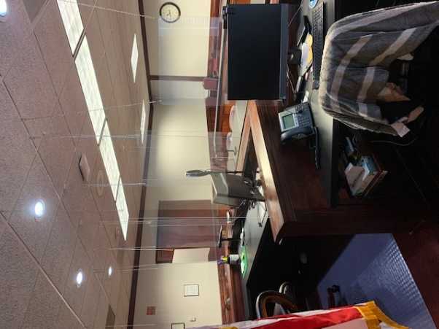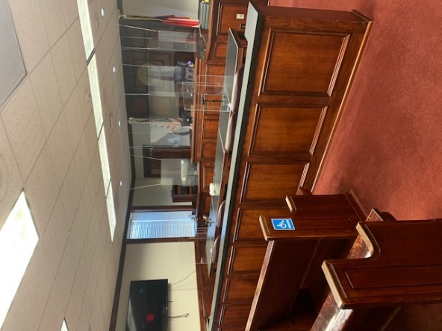
Changes in Calendaring and Attorney Appointment Procedure
We have had an increase in Petitions filed where removal and foster care is not being requested. In removal cases, the parents usually apply for an attorney at the PPH. In non-emergency cases, the parent often appears and asks for an attorney at the adjudication hearing. Adjudication hearings in non-emergency cases were being set 30 days out. We were seeing an unnecessary delay in services to the parent (such as the parent’s ability to enter into Family Treatment Court). After meeting with our Stakeholders, we made the following adjustments: the non-emergency adjudication hearing is set 10 days out instead of 30, the DFCS Case Manager encourages the parent to contact the court to apply for an attorney when the petition is filed.

Family Treatment Court
We have been working very hard to review and revise our policies and procedures and increase our Family Treatment Court census. Our DFCS office has been trained and is using the referral protocol. We have started receiving transfers from Superior Court. We have been receiving technical assistance and training from Children and Family Futures since October 2020. We have revised our Family Treatment Court policies and procedures manual, streamlined our referral process, created open lines of communication amongst our stakeholders, and implemented a second evidence based parenting course (Strengthening Families). As a result of our efforts, our Family Treatment Court referrals have increased 64% and our census has increased 250% since January 2021.
CASA
Our CASA Visitation Center is back open after being closed due to COVID-19 precautions. In addition to virtual family time and family time in the community, our families are able to utilize our CASA center for family time/visitation again.
Our CASA office received a donation of 25 Chromebooks from a local business and a plethora of medical/first aid/drug store supplies from another donor. These items are being distributed to our youth in foster care as needed.

